**Brazilian Jiu Jitsu Journal**

**03.14.2024**

**Mary Jines**

**SWDV 691 Capstone**

**Maryville University**

**PROJECT OVERVIEW**

The project I propose for my capstone is a web application titled “Brazilian Jiu Jitsu Journal”, which will serve as a journaling tool and tracker for athletes who practice the gentle art. The primary goal of the journal is to help athletes grow by documenting their sessions and techniques as they progress. It is no secret thanks to emerging sports psychology that mindfulness practices can improve athletic performance. The journal will give Brazilian Jiu Jitsu (BJJ) athletes a tool to practice mindfulness, reflect, and ultimately improve their game.

**CHALLENGES**

Brazilian Jiu Jitsu Journal will address two of the major challenges of learning BJJ.

The first of these challenges is the sheer complexity and vast collection of moves to learn. It generally can take anywhere from 10-15 years of consistent training to receive a black belt in this sport. In that time, you learn countless submissions, takedowns, transitions, escapes, guards, and combinations of each of these.

The second major challenge that the journal will help to address is stringing together related moves. In order to be successful at BJJ, not only do you have to remember the countless techniques you learn, but you have to become comfortable connecting them – knowing that one takedown will likely take you to a specific guard pass which leads to a specific submission, etc.

**SOLUTIONS AND INTERACTION**

In order to address the first challenge, the journal will provide athletes and coaches with a convenient place to record important information about training sessions and techniques that they learn, creating an invaluable resource for retaining information as they go. The primary offering of the application will be its “Training Journal” where users can record important information about a particular training session and the “Technique Library” where users will be able to create a library of the techniques they have learned. Both the Training Journal and Technique library will be searchable by different criteria in order to make reviewing specific entries from both simple, especially as the number of entries grows.

To address the second challenge, the journal will help to address stringing together related moves by allowing users to include related moves in a Technique Library Entry. In this way, the journal will help athletes keep track of the techniques and the techniques associated with them.

Uniting both the Training Journal and the Technique Library will be a simple, yet effective user interface that encompasses all aspects of the web application including a home and welcome page as well as user registration and authentication. In interacting with the web application, users would either register for or log into their account after which they could access either their Training Journal or Technique Library Dashboards from which they could view and search for specific entries as well as create new and edit/delete existing entries.

**PERSONAS**

The web application will target three main personas:

**BJJ Coaches** who are already passionate about BJJ and coaching and are looking for a resource to compile techniques to share with students

**Novices** who are looking for a way to keep track of all the new information they are learning

**Experts/Competitors** who are looking for a way to improve their game competitively.

****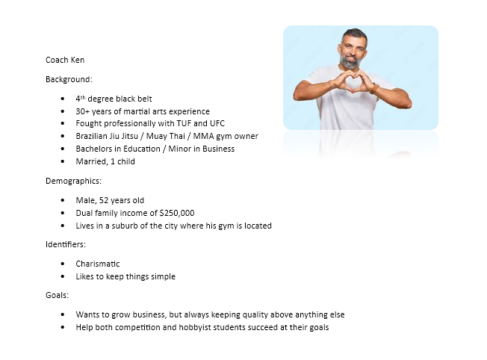

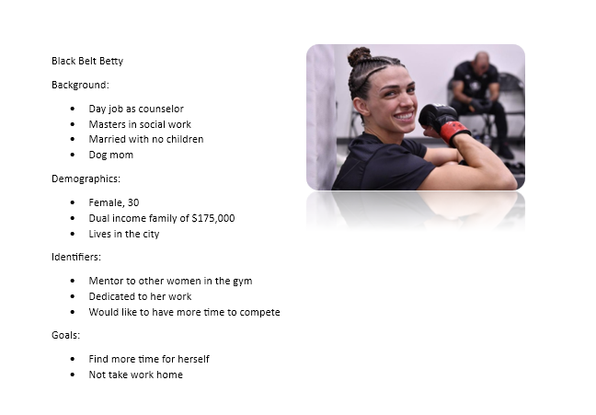

**VALUE**

The Brazilian Jiu Jitsu Journal offers value by providing a structured and organized way for athletes to track their progress in a complex sport. It will help athletes retain vast amounts of information, from different techniques to session feedback. Features like the ability to link related moves promote deeper understanding and smoother transition between techniques, which are critical for both competition and practice. The application also creates value for a variety of users, from novices to experts. Finally, its user-friendly interface ensures that users can focus on their training and reflection, instead of struggling with the tool itself, making mindfulness and strategic planning more accessible to the BJJ community.

**Minimal Viable Product (MVP)**

**OVERVIEW**

The core of the web application will be the user’s ability (through basic CRUD operations) to input new entries in their unique Training Journal and Technique Library after account creation and authentication. Users will be able to enter important information such as dates, descriptions, related technique, levels of proficiency, etc. in both their Training Journal and Technique Library in addition to both photos or videos related to the session or technique. In addition to the basic CRUD functionality of the app, users will also be able to filter and search for specific entries, making the review process simpler and the app over all more helpful for the athlete.

For the novice BJJ athlete, their use of the app might focus most on entry creation as they learn new skills and develop their technique library. They might also utilize the search and filter function as they inevitably forget something they learned and need a review.

Coaches or more seasoned athletes might initially create a large number of entries and utilize the search and filter function as they go about creating their game plan for a competition or are in search of inspiration for a lesson plan.

The MVP features I plan to implement for my application are listed below.

**FEATURES**

**I. User registration and authentication**

**II. Training Journal and Technique Library dashboards that display entries**

**III. CRUD operations for both the Training Journal and Technique Library**

**IV. Basic search functionality for the Training Journal and Technique Library**

**V. Simple home page to display a welcome and an explanation of the goal of the application**

If I have time, which I hope I will, I plan to add a couple extra features that pull data from the entries and display it in graph form for the user to be able to gain more insights from their entries, but the features above are the bare necessities for this app to function as I would like.

**SYSTEM ARCHITECTURE**

For this project, I plan to use the Django framework for both the front-end user interface and the backend service API. I will utilize the default SQLite database for this project although I would likely choose MySQL if I expected this application to easily scale up. I will likely use Amazon S3 for storing images.

Listed below are the major controller/service layers for my application:

**Training Session controller/service**

**Technique Library controller/service**

**User Authentication controller/service**

**Media Management controller/service**

**Search and Filter controller/service**

Finally, for deployment, I plan to use a free tier AWS EC2 instance.

**DATA FORMAT**

I plan to just use SQLite that works with Django as a default database. The tables and relationships required for my MVP are shown below. Organizing the data in this way allows for flexibility, especially with the media objects which can have many to many relationships with Training Sessions and Techniques. It also always for techniques to be associated with other techniques which as described previously is an important aspect of the functionality of the application.

**Tables:**

**_____________________________________________________________________________________**

**Users**

user_id (Primary Key)

username

email

password

**_____________________________________________________________________________________**

**TrainingSessions**

session_id (Primary Key)

user_id (Foreign Key to Users)

date

duration

notes (text area for journaling thoughts, feelings, etc.)

techniques

**_____________________________________________________________________________________**

**Techniques**

technique_id (Primary Key)

user_id (Foreign Key to User)

name

type (e.g., submission, escape, takedown)

description

proficiency_level

**_____________________________________________________________________________________**

**Technique Relationships**

relationship_id (Primary Key)

technique_id (Foreign Key to Techniques)

related_technique_id (Foreign Key to Techniques)

**_____________________________________________________________________________________**

**Media**

media_id (Primary Key)

user_id (Foreign Key to Users)

file_path (reference to the file location in AWS S3)

media_type (e.g., image, video)

upload_date

**_____________________________________________________________________________________**

**Technique Media**

technique_media_id (Primary Key)

technique_id (Foreign Key to Techniques)

media_id (Foreign Key to Media)

**_____________________________________________________________________________________**

**Session Media**

session_media_id (Primary Key)

session_id (Foreign Key to TrainingSessions)

media_id (Foreign Key to Media

**Design: User Interface**

**Site Map Overview**

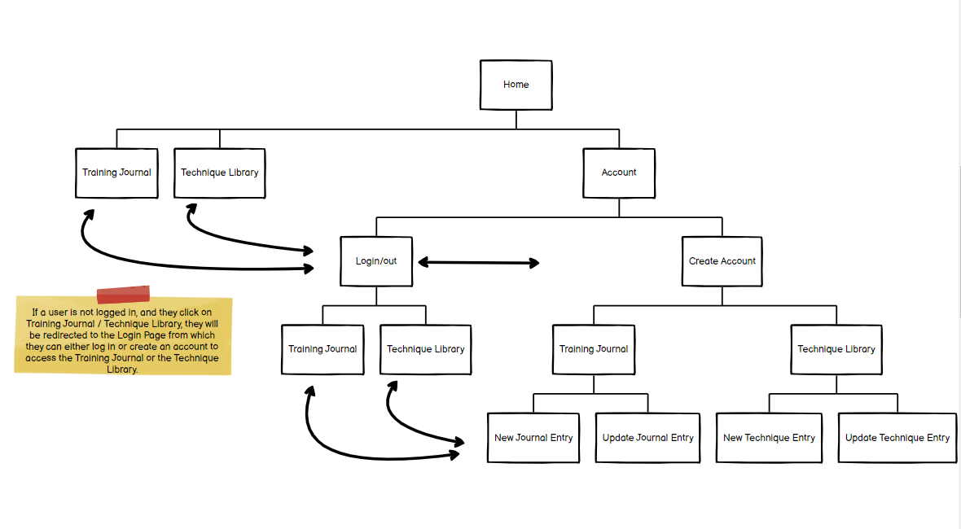

**Navbar**

|  |  |  |  |
| --- | --- | --- | --- |
| Home | Training Journal | Technique Library | Account |

Login/Logout

Create Account

https://bjjournal.com/home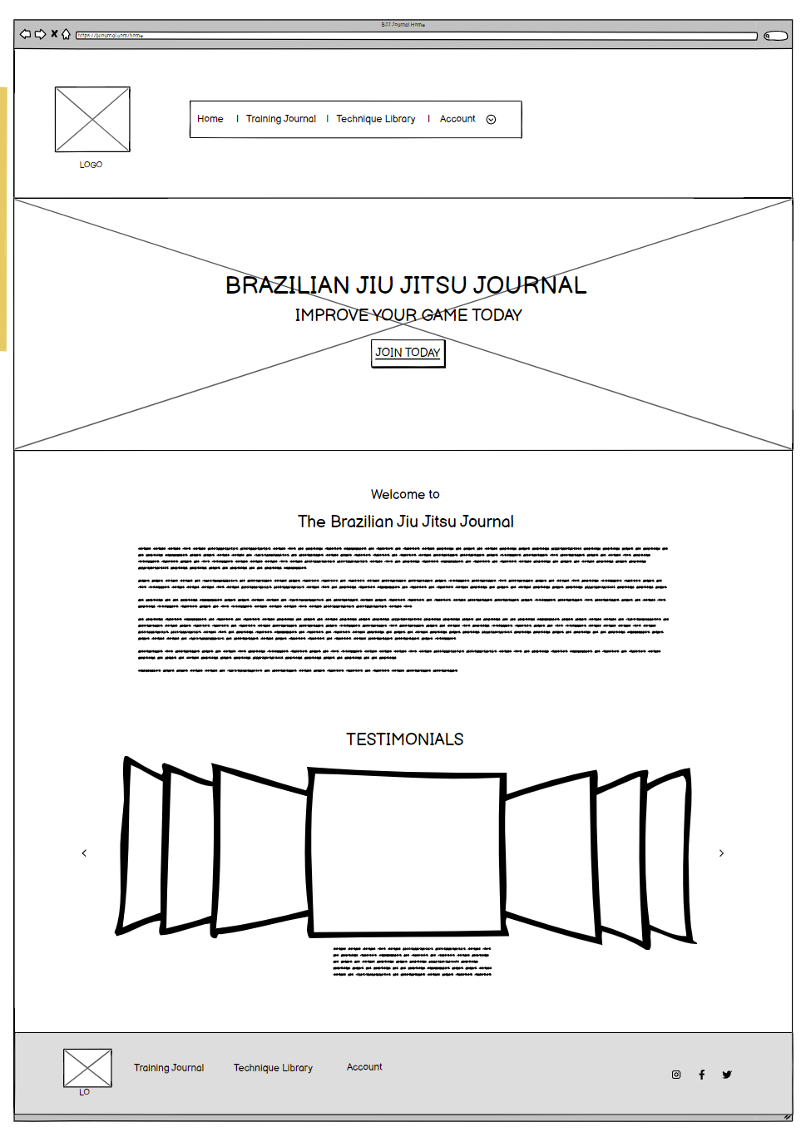/

https://bjjournal.com/login/

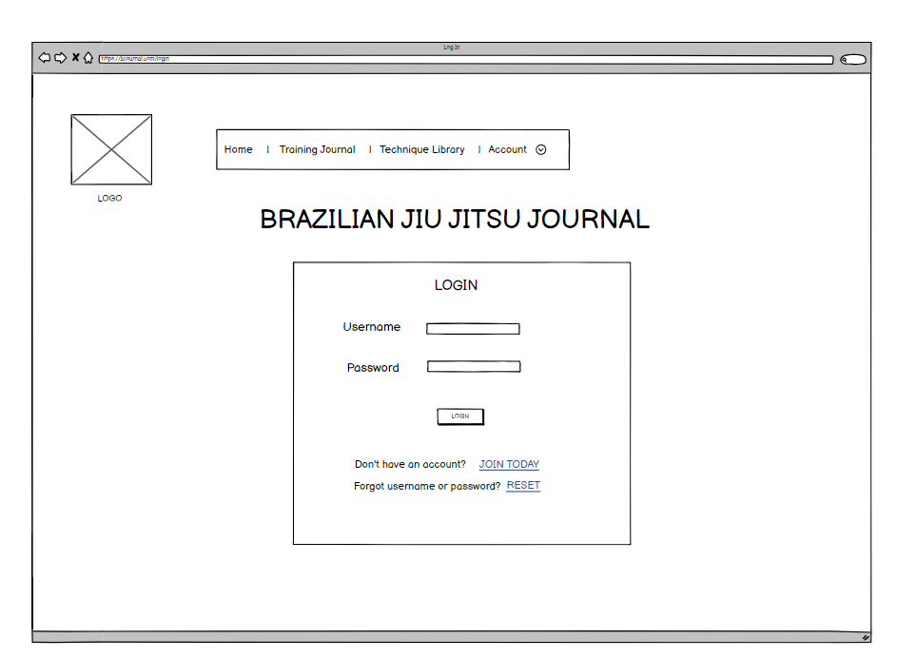

<https://bjjournal.com/createaccount>/

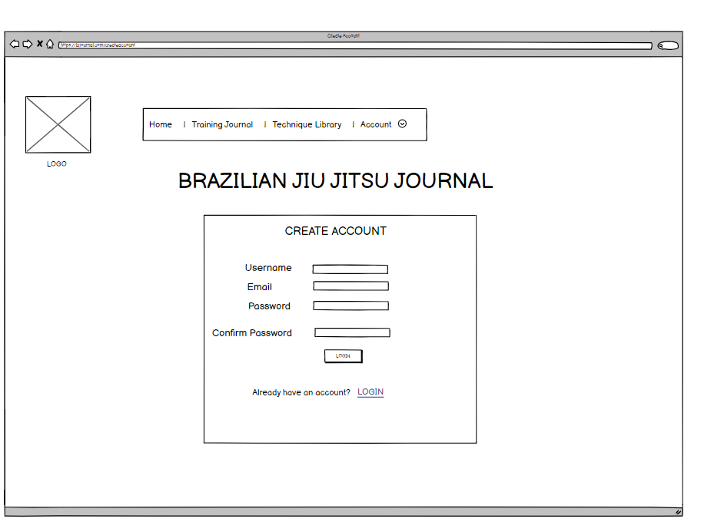

<https://bjjournal.com/trainingjournal>/

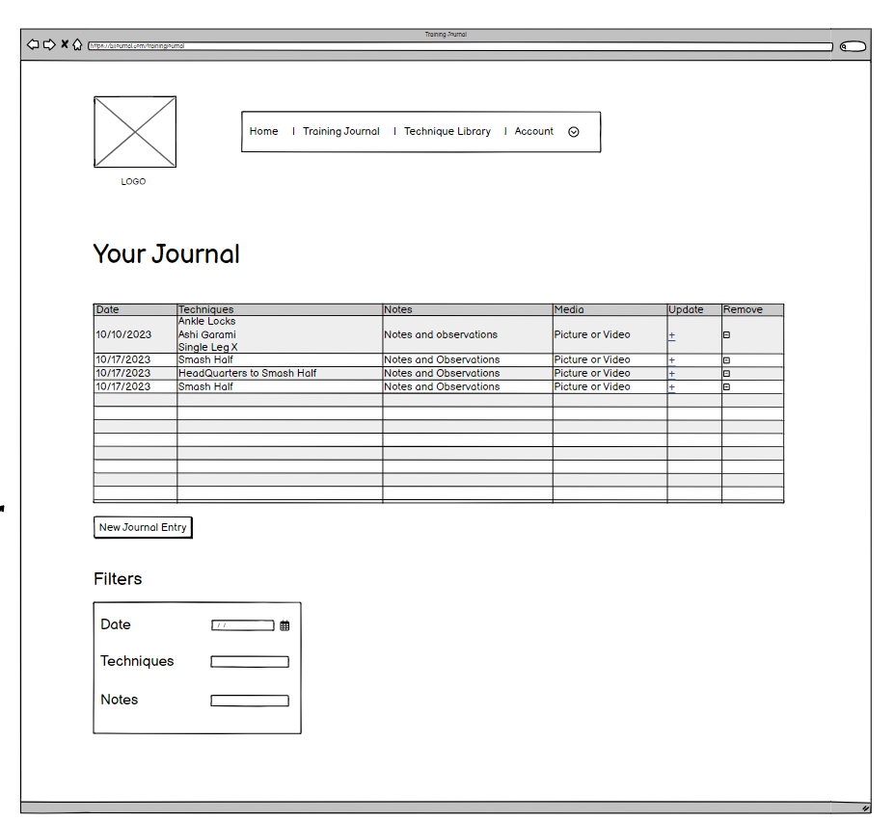

<https://bjjournal.com/techniquelibrary>/

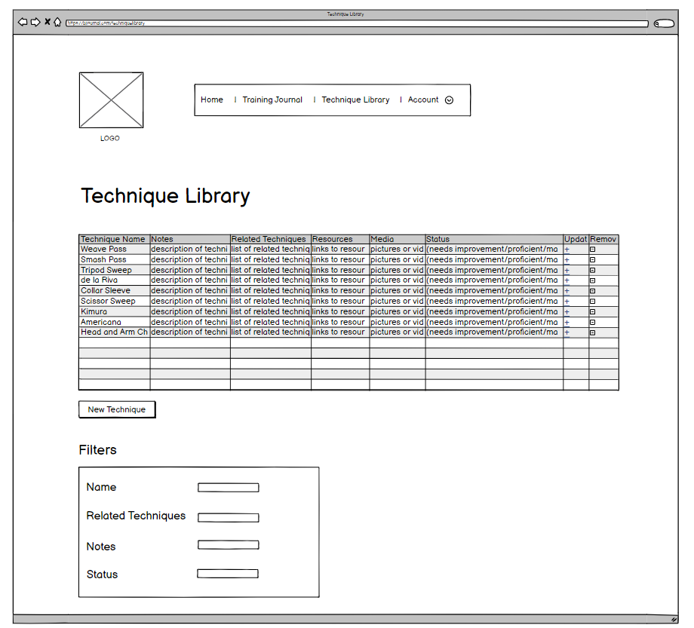

<https://bjjournal.com/trainingjournal/new/>

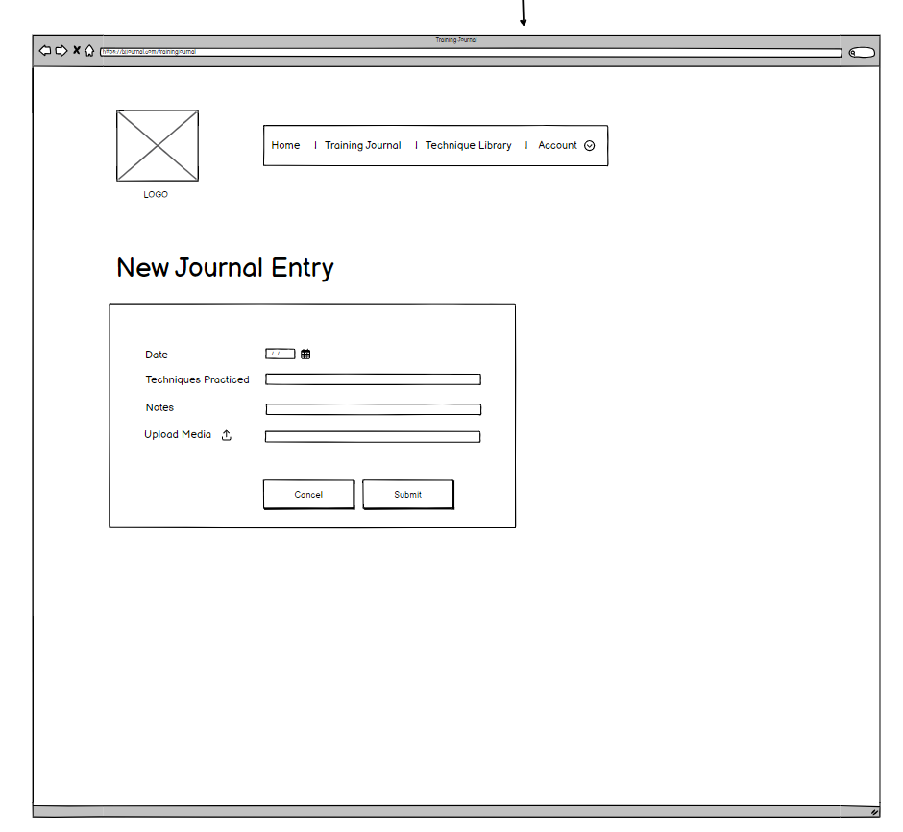

<https://bjjournal.com/techniquelibrary/new/>

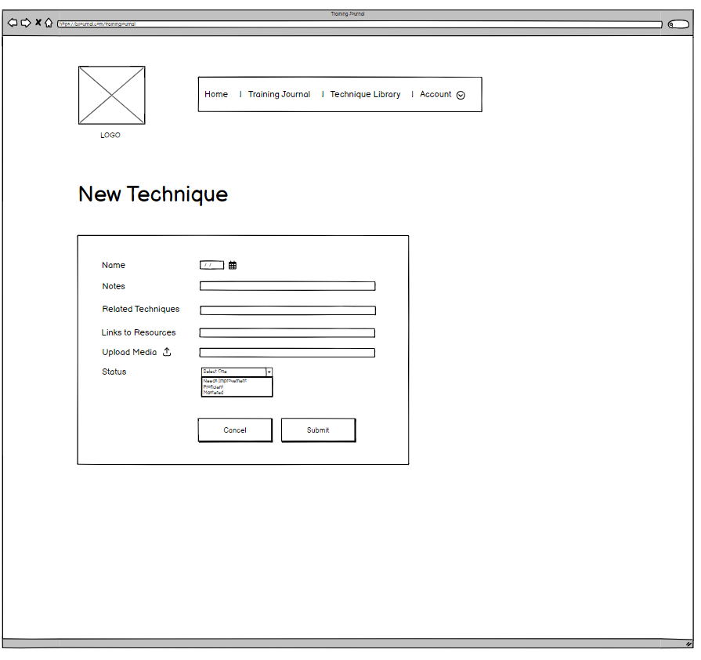

https://bjjournal.com/trainingjournal/update/session_id/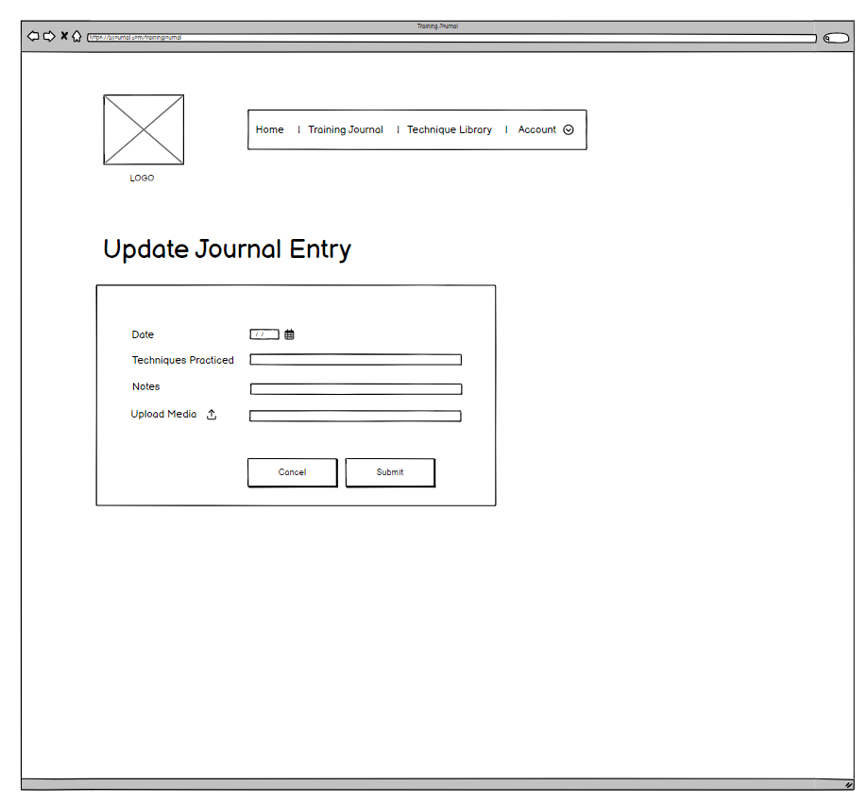

This would have the information originally input in the fields filled in automatically.

https://bjjournal.com/techniquelibrary/update/technique_id/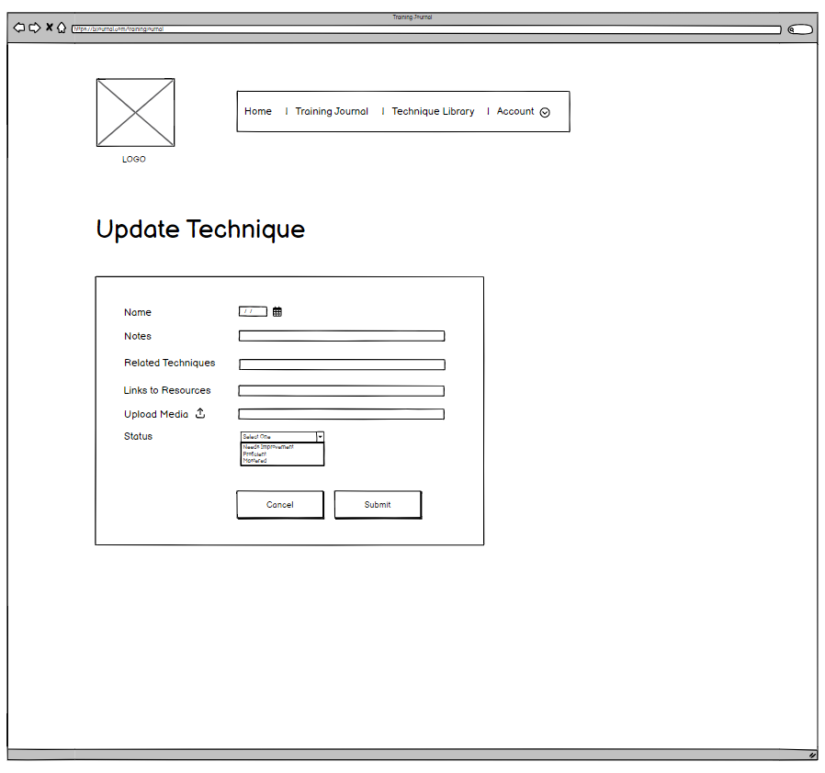

This would have the information originally input in the fields filled in automatically.

**Story Boards**

**For persona information, please refer to the persona previous persona section.**

**Story Board 1 and 1.2: Black Belt Betty and Coach Ken – both after extensive training in BJJ have made many entries to their Training Journal and Technique library. Coach Ken is looking for inspiration for the next month of lessons, and Black Belt Betty is preparing for a competition and wants to review submissions from the back.**

1. **From the homepage, they would select account, and from the drop down would select login.**





1. **They log in.**



1. **Coach Ken wants to remember the last time he went over passing from half guard, so he goes to the training journal and searches in the technique section for half guard. The entries remaining on the screen would show any entry in which he listed half guard as a technique. He sees the most recent date of those entries was from over a year ago. He decides to teach that in the upcoming quarter.**





1. **Betty needs to review submissions from the back. From the home page, she opens her technique library. From there, she searches for “rear naked choke” by name. The technique pops up and, in the entry, she clicks through the “related techniques” that are all submissions from the back. She goes to each of those entries and reviews her notes and the videos she uploaded to help jog her memory. She decides to train specifically the bow and arrow choke for the upcoming competition.**



**Story Board 2: White Belt Will – new to BJJ and new to Brazilian Jiu Jitsu Journal he creates and uses his account for the first time.**

1. **On the homepage, he reads about the app and various testimonials and decides to make an account. There are various ways to get to the account creation page. He can either select JOIN TODAY or Account and then Create Account. If he selects Training Journal or Technique Library he will also be directed to the login page where he can select create account.**





1. **Will is directed to the Create Account page where he creates an account**.
2. **Will hits submit and is redirected back to the homepage. He decides to make his first Journal Entry so he selects Training Journal.**





1. From the Training Journal Dashboard (his would be blank), he selects “New Journal Entry”





1. On the new entry page he enters in information from his most recent training session and clicks submit.





1. Submit takes him back to the training journal page where he can see his new entry displayed. He decides to also enter techniques in his Technique Library so he repeats the previous steps just with the technique library.

